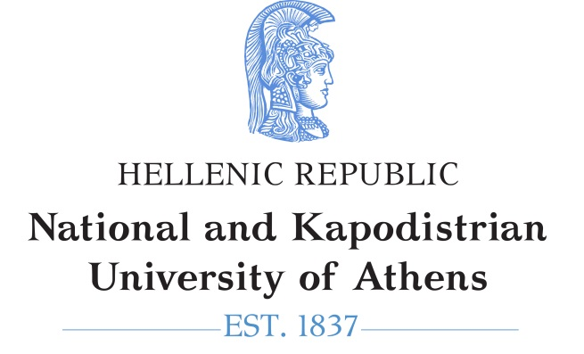 | 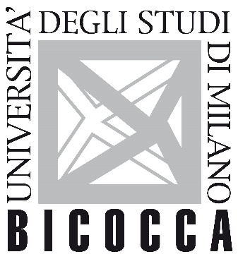

School of Medicine of National and Kapodistrian University of Athens
School of Medicine and Surgery (Dipartimento di Medicina e Chirurgia) of University of Milano−Bicocca

Postgraduate Cooperation Programme

"Endovascular Techniques"

Date: ……………

APPLICATION FORM

To
PCP Secretariat
First Name: | ……………………………………………………………………………..
Last Name: | ……………………………………………………………………………..
Father’s Name: | ……………………………………………………………………………..
Mother’s Name: | ……………………………………………………………………………..
Home address & phone no.: | ……………………………………………………………………………..
Mobile no.: | ……………………………………………………………………………..
Email: | ……………………………………………………………………………..

Please enrol me as a postgraduate student in the Postgraduate Cooperation Programme on Endovascular Techniques.

Fill in the following:

- Department that awarded the Main Degree, Year and Grade (in numbers):

……………………………………………………………………………………………
- Department that awarded the MSc (if applicable):

……………………………………………………………………………………………
- Degree or Certificate in English-language competence

………………………………………………………………………………………………

I hereby submit the following supporting documents:

- Application Form
- Curriculum Vitae
- Copy of degree or certificate of completion of studies
- Academic transcript of undergraduate studies
- Publications in peer-reviewed journals, if applicable
- Proof of professional or research activities, if applicable
- Photocopy of ID card, front and back
- Two letters of recommendation
- Certificate of language proficiency for English, B2 level
- Recognition certificate of Hellenic NARIC for recognition of their degree

The successful candidates will be selected by the Candidate Selection Committee based on the following criteria:
- Degree grade, which counts for 10%
- Grade average of undergraduate courses relevant to the object of the Postgraduate Programme, which counts for 10%
- Research activity, which counts for 10%
- Publications, which count for 10%
- Letters of recommendation, which count for 10%
- Degree studies related to health sciences count for 30%
- Certificate of language proficiency for English counts for 10%
- Certificate of language proficiency for any other foreign language counts for 10%

The applicant

Further information is available on the programme website: https://school.med.uoa.gr

